SWASTHYA SENSE — Workflow & Automation
Oct 31, 2026 · @Shama

1. Overview and automation principles
SWASTHYA SENSE automates the boring, repeatable work (finding overdue visits, sending reminders, applying rules, chasing escalations) and keeps every clinical decision with a human. One daily loop drives the whole product.
Step | What happens | Automated or human
1. Schedule | Follow-ups are generated from the patient's cohort template | Automated
2. Detect | Daily job finds due-soon, overdue and missed visits | Automated
3. Evaluate | Rule engine checks latest symptoms and measurements | Automated
4. Prioritize | Flags are scored and placed on each worker's worklist | Automated
5. Act | Worker sends a reminder, calls, visits, or escalates | Human
6. Review | Clinician reviews escalated cases and records the outcome | Human
7. Close the loop | Referral outcome and next follow-up are recorded; timers stop | Human, then automated
8. Audit | Every step above writes an audit entry | Automated
Automation principles
- Consent first: no job touches a patient whose consent is missing or withdrawn.
- Explain every output: a flag without a rule ID, inputs and version is never created.
- Human decides: automation may remind and route; it never diagnoses or closes a clinical case.
- Idempotent and safe to re-run: jobs use unique keys so a retry cannot double-send or double-flag.
- Fail loud, not silent: a failed job raises a visible alert for the admin and supervisor.

2. Patient lifecycle workflow
- Enrol: the worker creates a synthetic patient record with minimal fields and picks the cohort (hypertension, diabetes, pregnancy-related, post-illness).
- Consent: the worker records consent purpose, channel and language. Without it the record stays a locked stub and nothing else is possible.
- Assign schedule: the system applies the cohort's follow-up template (interval, grace period, reminder offsets) and creates the first follow-up tasks.
- Remind: reminders go out at the configured offsets, for example 2 days before and on the due date.
- Check in: at a visit or by message reply, the worker logs symptoms from a checklist and basic measurements.
- Evaluate: the rule engine runs on the new data and may raise a flag; the next follow-up is scheduled automatically.
- Escalate when needed: a clinical alert or a worker concern creates an escalation to a clinician.
- Close or continue: the patient stays on schedule until discharged from the programme, after which the record is archived.
- Withdraw consent at any time: messaging and further data entry stop immediately, and the record reverts to a minimal stub.
Follow-up status values: scheduled, due soon, overdue, missed, completed, cancelled. A follow-up becomes missed when it passes the grace period with no completed check-in.

3. Daily automation jobs
Times are configurable defaults in IST. Each job writes a run record and an audit entry.
Job | Default schedule | What it does | Safety checks
Schedule generator | On enrolment and after each completed visit | Creates the next follow-up from the cohort template | Skips patients without active consent
Overdue detector | Daily 06:00 | Moves follow-ups to due soon, overdue or missed | Uses grace period; idempotent per follow-up and day
Rule evaluator | On every new check-in, plus nightly sweep at 06:15 | Applies the rule set to latest data and trends | Stores rule ID, version, inputs; dedupes active flags
Reminder dispatcher | Daily 08:00 and 17:00 | Sends simulated SMS/WhatsApp reminders due at that time | Consent, quiet hours, max reminders per patient per day
Worklist builder | Daily 06:30 and on flag change | Scores and ranks each worker's list | Clinical alerts always outrank administrative ones
Escalation watchdog | Every 15 minutes | Checks SLA timers on open escalations | Reminds the clinician, then notifies the supervisor
Audit integrity check | Nightly | Verifies the audit chain is unbroken | Raises an admin alert on any gap
Reminder rules: the default offsets are 2 days before, on the due date, and 1 day after; a third missed attempt stops automatic messages and creates a worker task for a home visit or call. Quiet hours (default 20:00 to 07:00) block sends.

4. Risk-flag evaluation pipeline
The pipeline is a fixed sequence, so the same input always gives the same flag and the same explanation.
- Trigger: a new check-in, a status change, or the nightly sweep.
- Gate: confirm consent is active and the patient is assigned to a worker.
- Load context: latest symptoms, last 3 to 5 measurements, schedule status, active flags.
- Run rules: every active rule of the patient's cohort runs against the context.
- Classify: a match is tagged administrative reminder, administrative escalation or clinical review alert.
- Explain: the engine builds the "Why flagged" text from the rule's template, filled with the actual values.
- Dedupe and update: an identical active flag is refreshed, not duplicated; a flag whose condition clears is marked resolved with a reason.
- Score: compute the priority score from class, days overdue, stacked flags and cohort weight.
- Route: administrative items go to the worker's list; clinical alerts go to the list with an "Escalate to clinician" prompt.
- Audit: write rule ID, rule version, inputs, output and time.
Wording rule baked into templates: flags say "needs review" or "follow up", never "has" or "likely". A clinical alert always ends with "Prototype rule. Not a diagnosis. Clinician review required."
Flag lifecycle: open, acknowledged by worker, escalated, resolved (condition cleared or clinician outcome), dismissed with a required reason. A dismissed clinical alert is visible to the supervisor.

5. Escalation and referral state machine
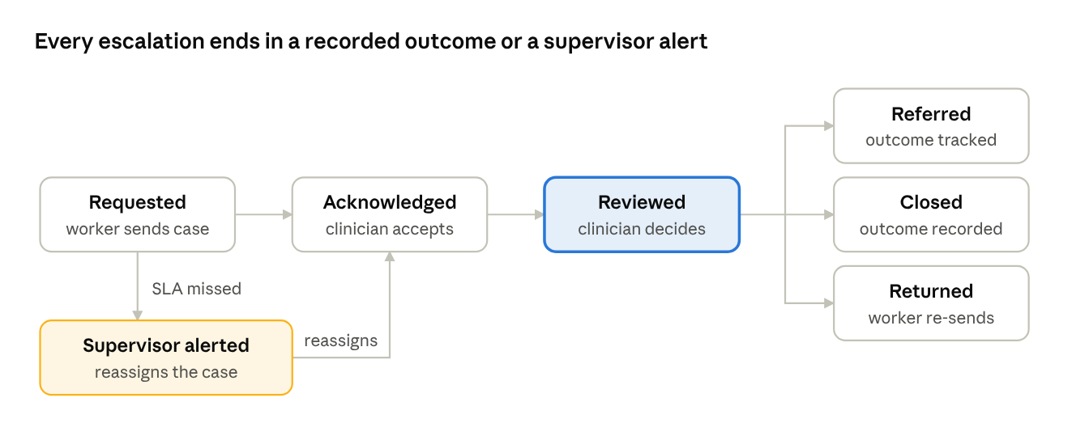
escalation states · 6 states, 1 SLA fallback
A case moves forward only by a human action; the one automatic transition is the supervisor alert when a deadline is missed. Every transition writes an audit entry.
Stage | Default SLA (admin-configurable) | If the SLA is missed
Requested to Acknowledged | 4 hours | Reminder to the clinician at 50% of the time; supervisor alert and reassignment at 100%
Acknowledged to Reviewed | 24 hours | Supervisor alert; worker sees "awaiting clinician"
Referred to outcome recorded | 7 days | Nudge to the worker and supervisor to confirm the patient reached care
Returned to re-sent | 24 hours | Task stays on the worker's list at top priority
Escalation summary sent to the clinician (minimum data): pseudonymous ID, age band, cohort, the flag and its "Why flagged" text, last 3 measurements, reported symptoms, last follow-up date, worker's note. No contact details are included.
Fallbacks
- No clinician available: the supervisor reassigns to an alternate clinician; the worker is told who now owns the case.
- Patient unreachable: the worker logs a failed contact; after three failed attempts a home-visit task is created.
- Emergency notice: SWASTHYA SENSE is not an emergency service. For anything that looks like an emergency the worker follows the local emergency protocol first and logs the case afterwards. This notice is shown on every clinical alert.

6. Simulated SMS and WhatsApp messaging
No real messages are sent. A messaging simulator mimics a gateway so the full flow, including patient replies, can be demonstrated safely.
Message lifecycle: queued, sent, delivered, replied, failed. The simulator can inject delays, failures and replies so the demo can show retry and fallback behaviour.
Templates (short, plain, three languages in the build; English shown here)
Template | Trigger | Example text
Upcoming visit | 2 days before due | "Hello. Your health check is due on 14 Nov. Reply 1 to confirm, 2 to reschedule."
Due today | Due date | "Your health check is today. Please visit the centre or reply 2 for a home visit."
Missed visit | 1 day after due | "We missed you at your health check. Reply 1 if you can come this week."
Symptom check-in | Scheduled remote check-in | "How are you feeling? Reply 1 if well, 2 if you have a problem. Your health worker will call you."
Consent confirmation | After enrolment | "You agreed to health reminders. Reply STOP anytime to stop."
Reply handling
Reply | System action
1 (confirm / well) | Mark reminder answered; keep schedule; log check-in note
2 (reschedule / problem) | Create a worker task to call the patient; if the symptom check-in was answered with a problem, raise a "worker to review" item (not a clinical diagnosis)
STOP | Withdraw messaging consent immediately and audit it
Anything else | Store as unparsed, create a worker task to call
Safeguards: messages contain no condition names or measurements; each patient has a daily cap and quiet hours; templates are approved text, never free-form; a failed send creates a worker task instead of silent loss.

7. Audit trail, error handling and human checkpoints
Audit entry fields: event ID, timestamp, actor and role, action, patient pseudonym, object (flag, message, escalation), before and after values, reason, result, and a hash linking to the previous entry so tampering is detectable.
Event class | Examples
Access | Patient opened, list viewed, access denied
Data change | Check-in logged, schedule edited, consent changed
System decision | Flag raised or resolved, score computed, reminder sent
Workflow | Escalation requested, acknowledged, reviewed, referred, closed
Admin | Rule or threshold changed (with version and approver), user or role changed
Error handling
Failure | Response
Job crashes midway | Resume from checkpoint; idempotency keys prevent duplicates; admin alert raised
Message send fails | Retry twice with backoff, then create a worker task
Rule engine error on one patient | Skip that patient, mark "needs manual review" and log; never silently drop
Missing data (no recent measurement) | Treat as a data gap: raise an administrative reminder to collect it, never assume normal
Clock or schedule drift | Use server time in IST with stored timezone; nightly consistency sweep
Human-in-the-loop checkpoints: the clinician approves rule changes before they go live; only a clinician records the outcome of a clinical alert; dismissing a clinical alert needs a reason and is visible to the supervisor; consent changes are always applied immediately and never reversed by automation.

8. Worked scenarios for the live demo
All patients are synthetic. Thresholds shown are illustrative placeholders, not clinical advice.
# | Scenario | What the system does | What the judges see
1 | Hypertension patient misses a visit by 3 days | ADM-OVD-02 raises a blue reminder; worker taps to send a WhatsApp reminder | Reminder vs clinical distinction; simulated reply clears the flag
2 | Same patient misses a second visit | ADM-MISS-03 raises an amber alert; supervisor is notified; home-visit task created | Escalation path without a clinician
3 | Three rising BP readings, last one above the configured limit | CLIN-BP-02 raises a red alert with the readings, limit and rule version | "Why flagged" panel and clinician routing
4 | Pregnancy-cohort patient reports a danger-sign symptom by reply | CLIN-SYM-01 raises a red alert and shows the emergency notice | Safe wording, no diagnosis, fast escalation
5 | Clinician does not acknowledge in time | Reminder at 50% of the SLA, supervisor alert at 100% | Closed-loop, no case lost
6 | Patient replies STOP | Consent withdrawn, messaging halted, record locked to a stub | Consent control that works instantly
7 | A supervisor tries to open a patient's contact details | Access denied and written to the audit log | RBAC and audit trail
8 | Admin changes a threshold | New rule version created; requires clinician approval before activation | Governed, versioned, transparent rules

